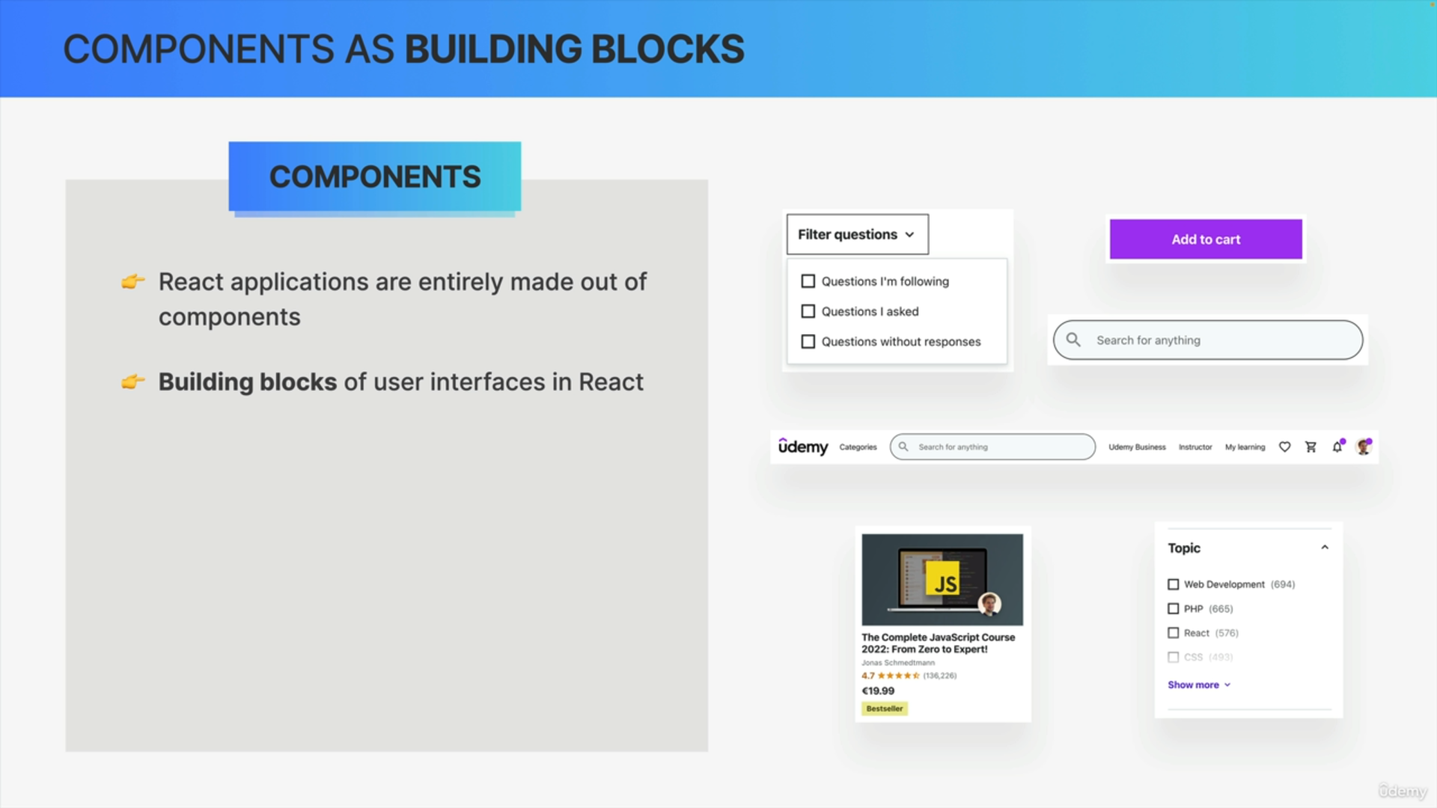

Components are fundamental concept in REACT. React applications are entirely made out of components. Components are the building blocks of user interfaces in REACT.

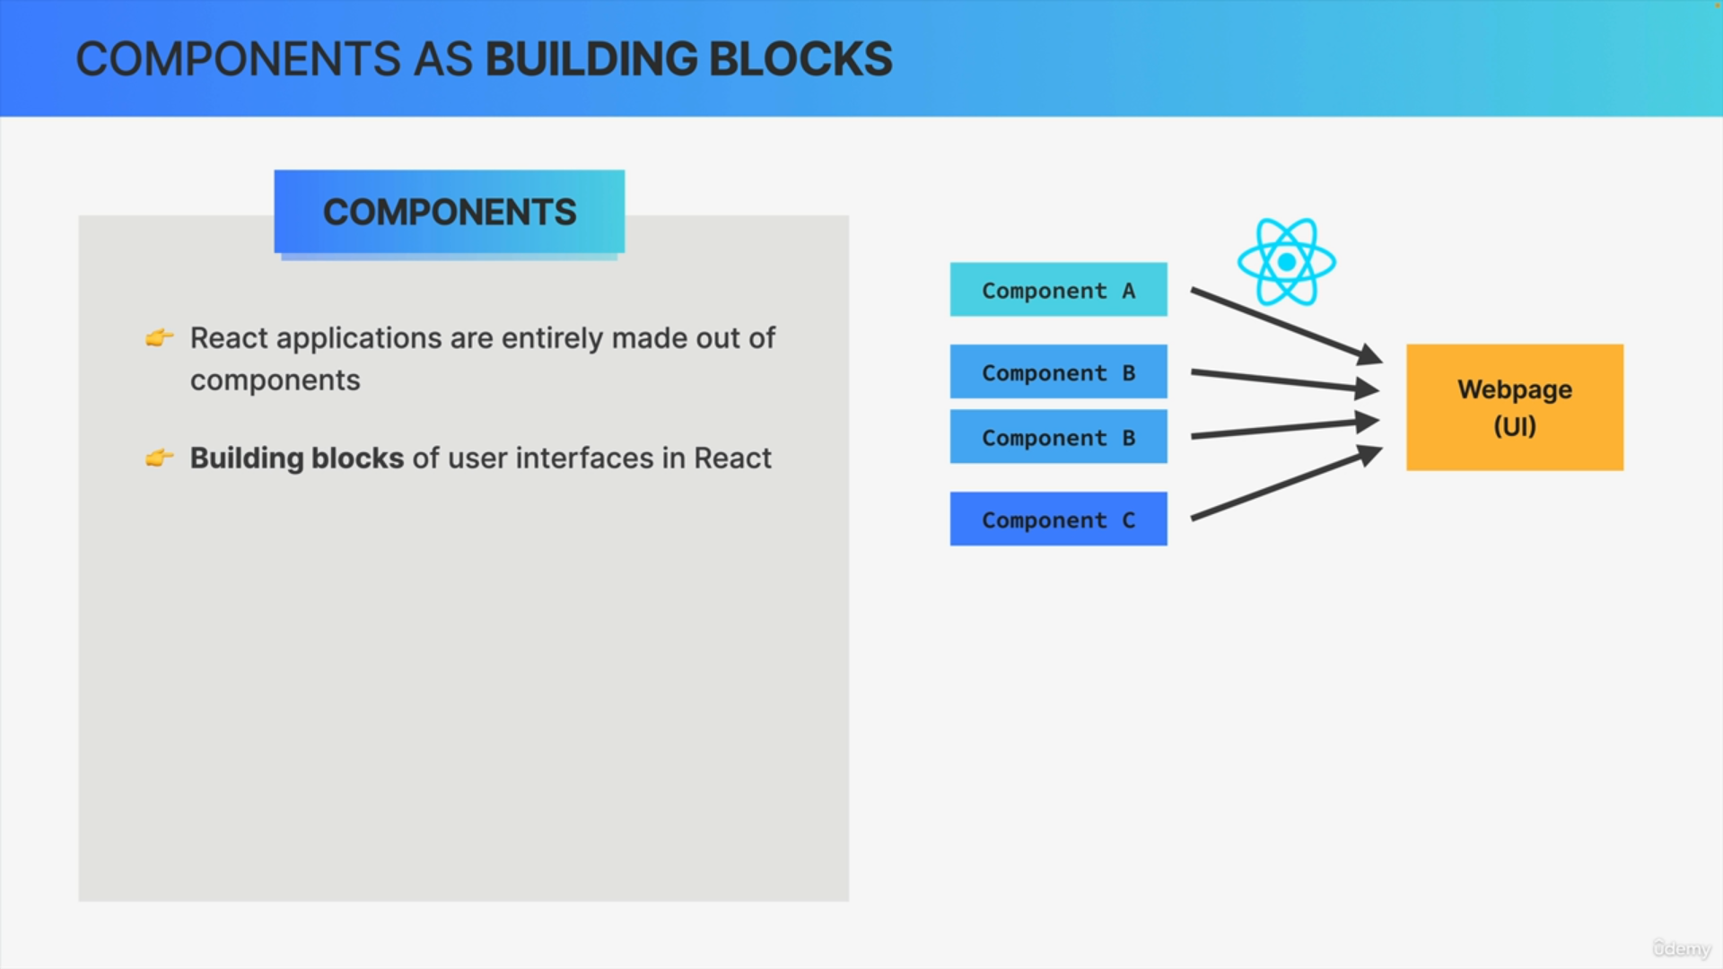

REACT takes components and draw them on the webpage. REACT renders the view for each component and all these views together make up the user interface.

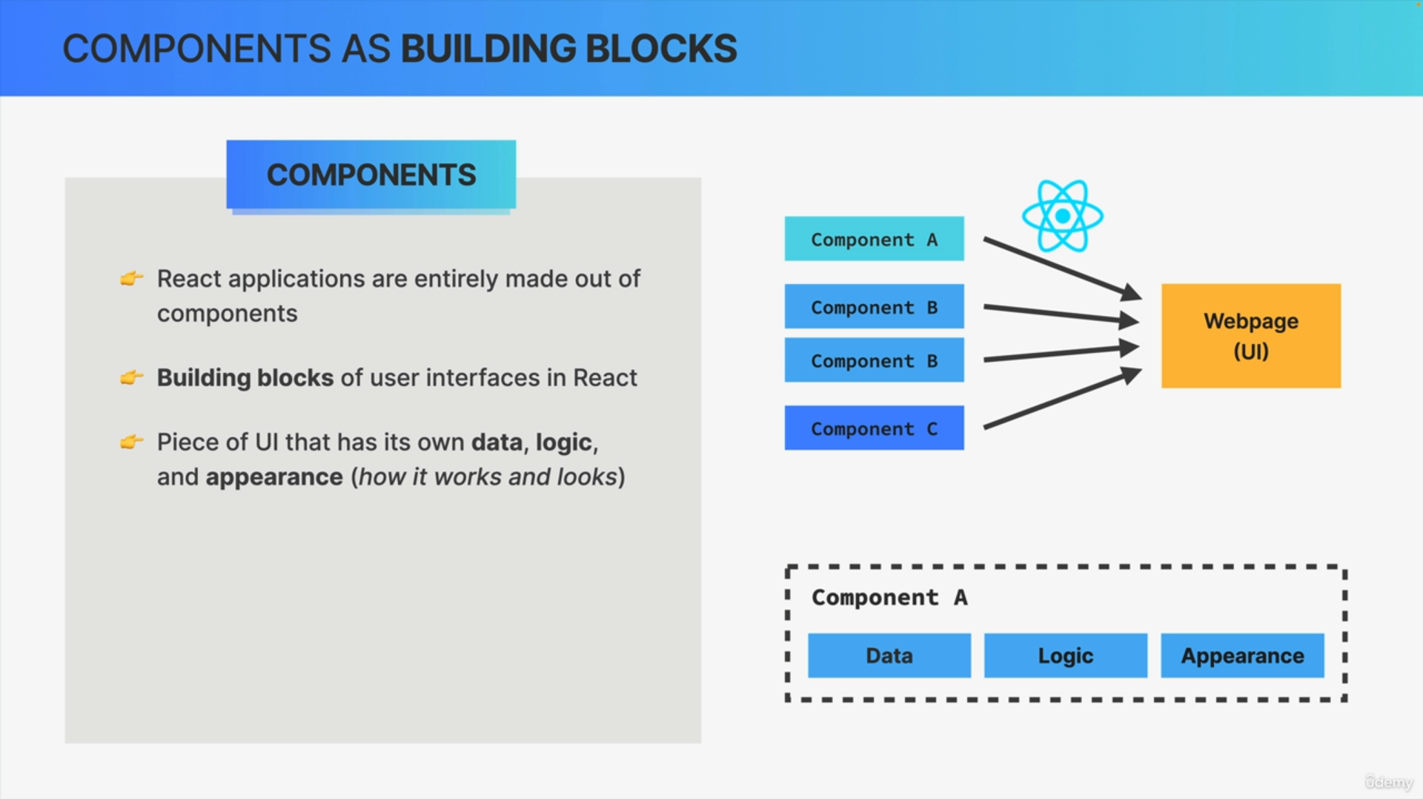

We can also think of component as piece of user interface. Each component has its own data, JAVASCRIPT logic and appearance. Each component describes how it works and how it looks like.

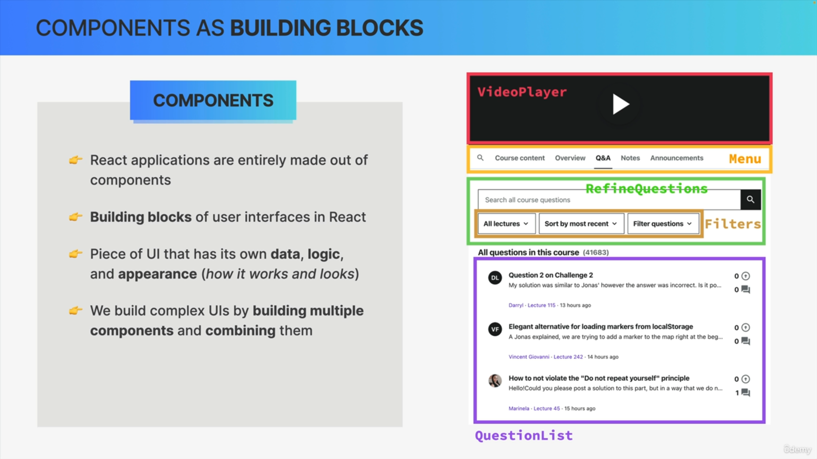

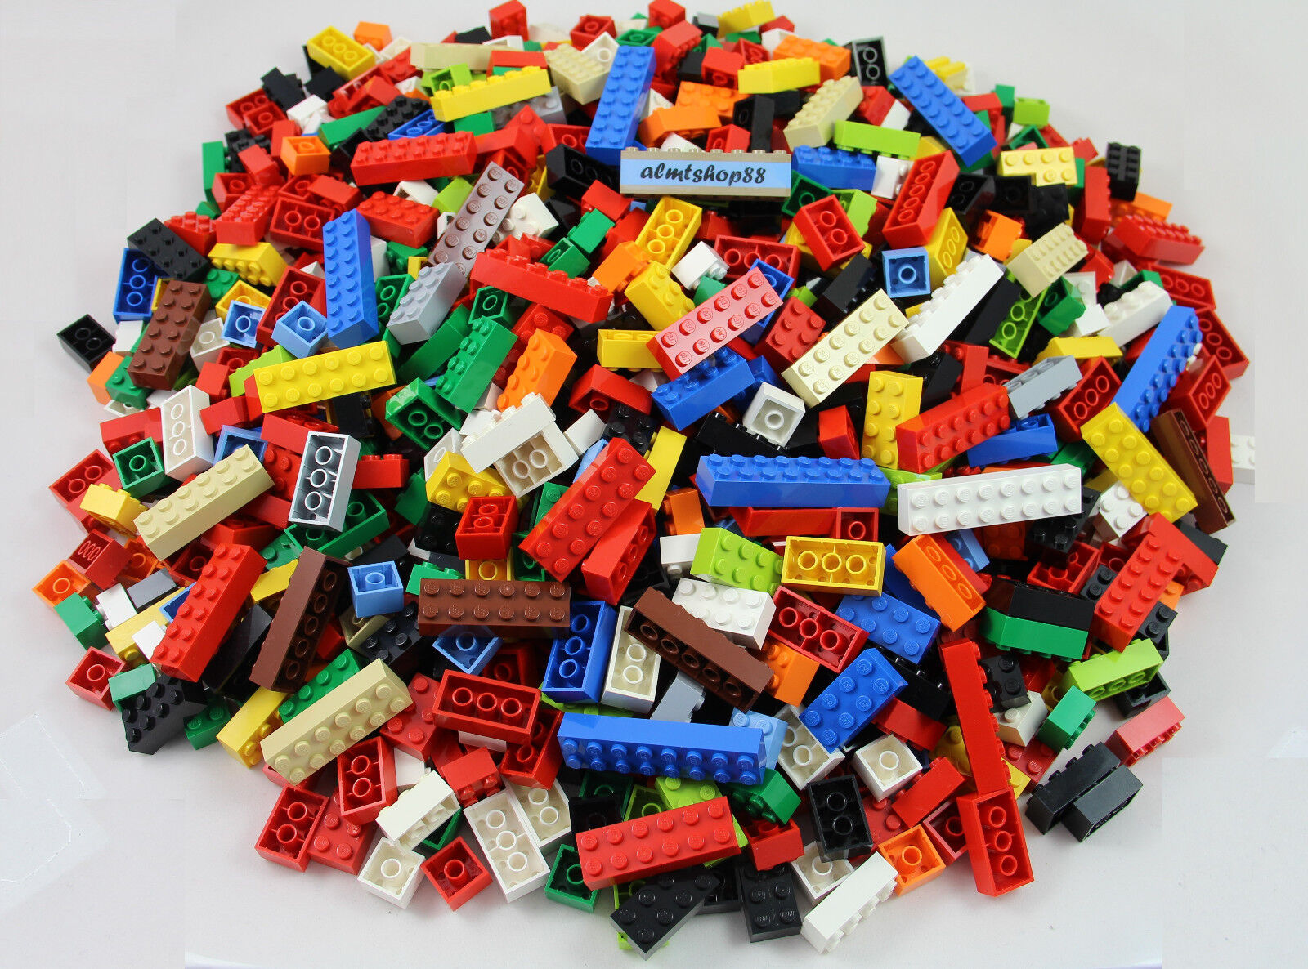

In REACT, we build complex UIs by building multiple components and then combining these components like LEGO pieces.

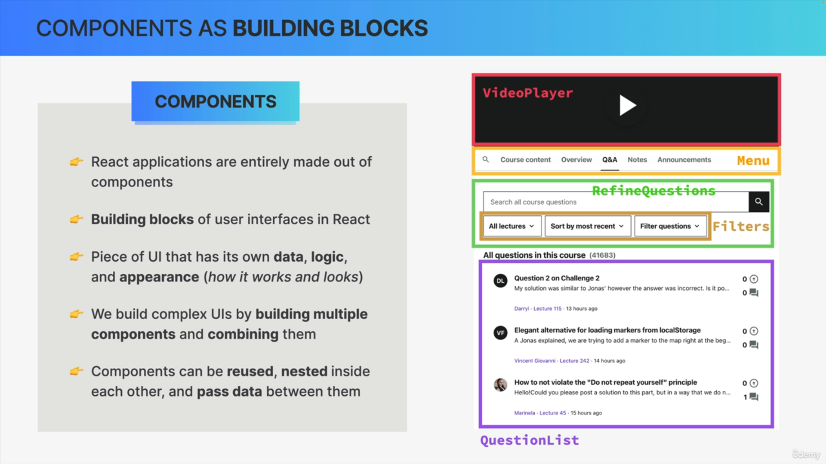

Components can be reused and can be nested inside other components. So, nesting components and components reusability are the key aspects of using components in REACT.

